PIZZA SALES SQL QUERIES

- KPIs
- Total Revenue:
SELECT SUM(total_price) AS Total_Revenue
FROM pizza_sales;
Output:
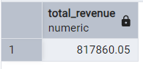

- Average Order Value:
SELECT SUM(total_price)/COUNT(DISTINCT order_id) AS Average_Order_Value
FROM pizza_sales;
Output:
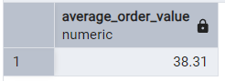

- Total Pizza Sold:
SELECT SUM(quantity) AS Total_Pizza_Sold
FROM pizza_sales;
Output:
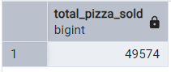
- Total Orders:
SELECT COUNT(DISTINCT order_id) AS Total_orders
FROM pizza_sales;
Output:
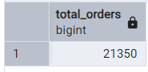

- Average Pizza Per Order:
SELECT ROUND(SUM(quantity)::numeric / COUNT(DISTINCT order_id),2) AS pizza_per_order
FROM pizza_sales;
Output:
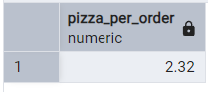

- Charts Requirement:
- Daily Trend for Total Orders:
SELECT
TO_CHAR(order_date, 'Day') AS Order_Day,
COUNT(DISTINCT order_id) AS Total_Orders
FROM pizza_sales
GROUP BY TO_CHAR(order_date, 'Day');
Output:
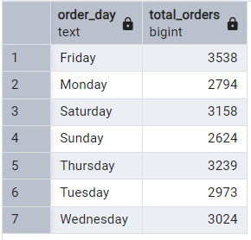

- Monthly Trend for Total Orders:
SELECT
TO_CHAR(order_date, 'Month') AS Month_name,
COUNT(DISTINCT order_id) AS Total_Orders
FROM pizza_sales
GROUP BY Month_name
ORDER BY Total_Orders DESC;
Output:
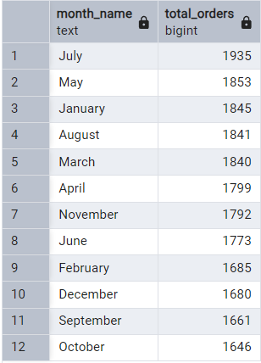

- Percentage of Sales by Pizza Category:
SELECT
pizza_category,
ROUND (SUM (total_price),2) AS Total_Sales,
ROUND (SUM(Total_price)* 100 / (
SELECT SUM(total_price) FROM pizza_sales),2) AS "%_Total_Sales"
FROM pizza_sales
GROUP BY pizza_category;
Output:
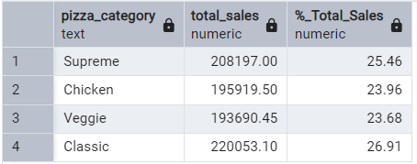

- Percentage of Sales by Pizza Size:
SELECT
pizza_size,
ROUND (SUM (total_price),2) AS Total_Sales,
ROUND (SUM(Total_price)* 100 / (
SELECT SUM(total_price) FROM pizza_sales),2) AS "%_Total_Sales"
FROM pizza_sales
GROUP BY pizza_size;
Output:
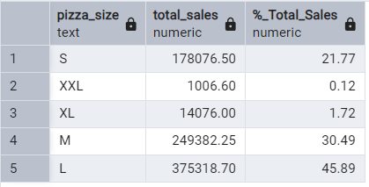

- 5 Best Sellers by Revenue, Quantity, and Orders:
Revenue:
SELECT
pizza_name,
ROUND (SUM (total_price),2) AS Total_Revenue
FROM pizza_sales
GROUP BY pizza_name
ORDER BY Total_Revenue DESC
LIMIT 5;
Output:
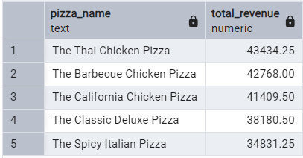

Quantity:
SELECT
pizza_name,
SUM (quantity) AS Total_Quantity
FROM pizza_sales
GROUP BY pizza_name
ORDER BY Total_Quantity DESC
LIMIT 5;
Output:
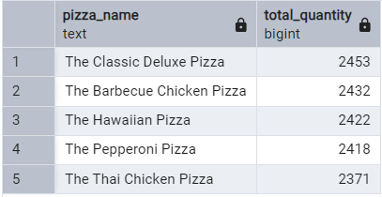

Orders:
SELECT
pizza_name,
COUNT (DISTINCT order_id) AS Total_Orders
FROM pizza_sales
GROUP BY pizza_name
ORDER BY Total_Orders DESC
LIMIT 5;
Output:
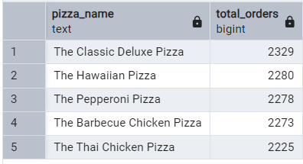

- 5 Worst Sellers by Revenue, Quantity, and Orders:
Revenue:
SELECT
pizza_name,
ROUND (SUM (total_price),2) AS Total_Revenue
FROM pizza_sales
GROUP BY pizza_name
ORDER BY Total_Revenue
LIMIT 5;
Output:
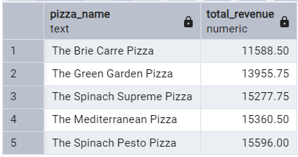

Quantity:
SELECT
pizza_name,
SUM (quantity) AS Total_Quantity
FROM pizza_sales
GROUP BY pizza_name
ORDER BY Total_Quantity
LIMIT 5;
Output:
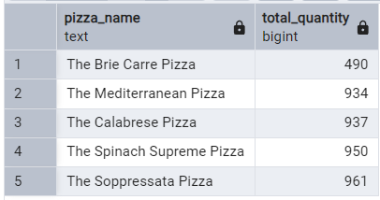

Orders:
SELECT
pizza_name,
COUNT (DISTINCT order_id) AS Total_Orders
FROM pizza_sales
GROUP BY pizza_name
ORDER BY Total_Orders
LIMIT 5;
Output:
